Interfacing SciScan with other Applications using ActiveX

This document outlines the technique used to set and get SciScan software variables from other applications. This has been tested with MATLAB and Python. Please refer to the relevant example script files (.m or .py) for the application you are interested int. These examples should be easily adaptable to other programming languages that support ActiveX.

# Points to note:

1. *GFG_Translator.vi* should NOT be added to the LabVIEW project of SciScan (or any other project). Calling a VI inside a project using this technique crashes LabVIEW
2. *FOCUS*, *Record* and *Cancel* cannot be set using the standard set method for Booleans due to restrictions enforced in SciScan. Please see the separate examples below to programmatically control *FOCUS*, *Record* and *Cancel*.

The state of the different components in SciScan are stored in a Generalized Functional Global variable (GFG) named GFG_Core.vi. To access this data (read/write) from outside the project, a ‘middleman’ *VI* called *GFGTranslator.vi* is made available.

**[Note for advanced users**:

*To access data stored in GFG_Core.vi in SciScan from outside the project, it is required to use the reference number of the GFG_Core, which gets written into a file <SciScan application path>\GFG\GFG_core.ref when SciScan starts up. Internally, the GFGTranslator.vi uses this reference number to gain access to the GFG_Core.vi. Please refer to the LabVIEW code of GFGTranslator.vi for more details.* **]**

# *GFGTranslator.vi* usage instructions:

1. Using windows explorer, ensure that GFGTranslator.vi is present in your SciScan root folder. Note that this will NOT be visible in your *Sci_Scan.lvproj* LabVIEW project. It should NOT be added to the SciScan project (or any other project). Calling a VI inside a project using this technique crashes LabVIEW
2. Run SciScan
3. Open the script file (Python/MATLAB) and make the following changes:

* Set the path to the GFG_translator.vi

1. Python Example

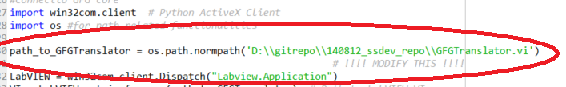

1. MATLAB Example

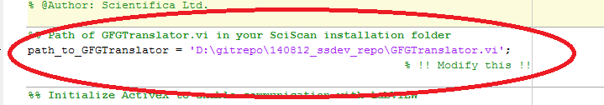

* Navigate to the code snippet relevant to the action (*get, set*) and data type (*string, path, numeric, boolean, booleanref, all, variant (Read Only), image (Read Only)*). Read examples (“Get”) can be found in 'Example A' and write examples (“Set”) can be found in 'Example B'.

1. Python Example

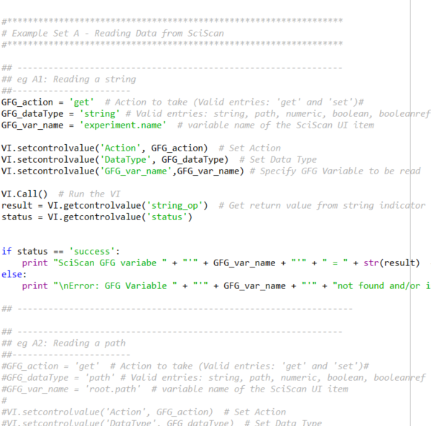

1. MATLAB example

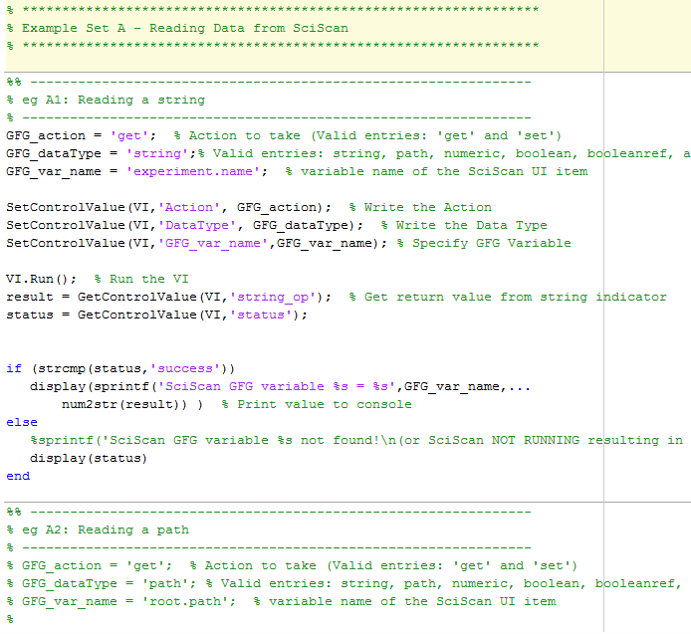

1. Un-comment the relevant code snippet and run the Script to execute the selected example.
2. Once you are familiar with the calling conventions for the different data types, you can modify the examples and incorporate them into your own code to control SciScan from within your existing work flow

# *FOCUS*, *Record* and *Cancel*

*FOCUS*, *Record* and *Cancel* cannot be set using the standard set method for Booleans due to restrictions enforced in SciScan. To set these controls programmatically; for example, to programmatically trigger a ‘Record’ use the *booleanref* data type as shown in the following examples:

1. Python Example

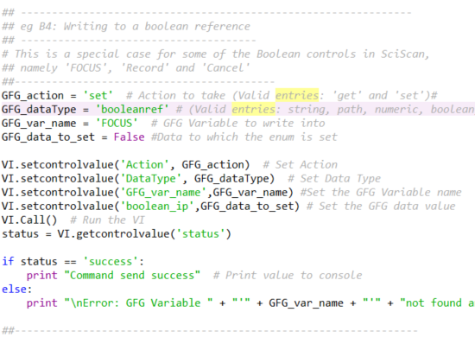

1. MATLAB Example

